Planning Packet
This Planning Packet is designed to collect and organize all your event’s important details so that we can flawlessly facilitate your event day-of.
You will be responsible for updating this information and submitting it to us within a 3-month window of your event so that we can review and finalize it with you. We are happy to consult you along the way to make the planning process easier!
Please fill in all applicable information to the best of your ability in a different color and be sure to delete all examples given below.

Event Information
Event date:
Venue:
Ceremony location:

Event Time (per your contract):
Guest arrival-
Ceremony begins-
Reception begins-

Couple’s first names with phone numbers:
Important contact Name and phone number:
Day-of/on-site contact name and phone number:

(your day-of/on-site contact is a hired professional or friend/family member designated to help set-up and then remove all items at the end of the night / please designate a vehicle for items and gifts / all items must be removed night-of and we are not responsible for any items that are left behind / any cars that are left on property overnight, must be removed by 10am the following day)

Ceremony Rehearsal Walk-through
(per your contract)
Date:
Time:

Timeline
Day-of/pre-event details:
Your scheduled day-of event venue manager and service staff is on-site 3-hours prior to the event setting up your floorplan and tables, dropping linens, and building the bar/buffet. We allow your vendors to deliver, set-up, and decorate within that 3-hour window so that we are on-site to help oversee and direct them. We allow you and your bridal party to arrive no earlier than 1-hour prior to your guest arrival time or reception time (if no ceremony is taking place on-site). The Lakehouse does not have a holding area for bridal party. Maison Lafitte has a bridal suite that is available within that 1-hour window. All on-site, pre-event photography must be done within the 1-hour window, no exceptions. You can coordinate a pre-event timeline including photography details directly with your photographer or wedding planner.)
Please include the following information and any other details you believe are important:
- Where are you getting ready?
- Do you plan on arriving at the venue early? If so what time?
- Are you putting your dress on at the venue?
- Will you be using the bridal suite (only applicable to Maison Lafitte)?
- Are you planning a “first look” with your photographer? If so, what time?
- Additional notes:

Ceremony
If your ceremony is located at our venue, please fill in the following information and include any other details you believe are important:
- Where on property is your ceremony located? (example- Maison Lafitte Front of the House or Pavilion, if using the Pavilion, there is an additional $500 fee to flip to reception following the ceremony)
- What type of music will you have for your ceremony? (example- Violinist or DJ)
- What type of Décor will you provide? (example- “I have hired a florist, she will be hanging a drape in center arch and setting up two large arrangements on either side of handrails, these arrangements will be moved and reused to two 60” round tables for the reception. We also have a welcome sign on an easel that we would like outside the front gate.”)
- Do you have any need for a table at the altar? (example- lighting of a unity candle, sand ceremony, signing of marriage certificate)
- Additional notes:

No two wedding ceremonies are alike. Even if some couples say the same vows or take a deep dip for the kiss, every pair has a unique mix of things as it comes to their officiant, remarks, ring exchanges, recessional and more. That said, the below is a traditional wedding ceremony order of events to guide your preferences. We have used a timeframe starting with 0 o’clock to represent the timeframe in between each item on the timeline, please fill in your actual times in place of our examples.

00:00 Guest Arrive; this typically begins approximately 30 minutes prior to the time on your invitation, please reference your contract time. It is often nice to have music playing while guests choose their seats.

00:30 The Procession / Ceremony Begins
This is the part where the wedding party walks down the aisle and takes their places for the ceremony. You can each make your way to the altar separately, symbolizing the fact that you're coming from different backgrounds. In a Christian procession, the bride is escorted by her father, while the groom waits for her at the altar. In a Jewish procession, the groom's parents escort him down the aisle, and then the bride's parents escort her down the aisle.
The Officiant's Opening Remarks
You've heard it a hundred times: "Dearly beloved, we are gathered here today..." Or some start by saying, "Friends and family..."
The Officiant Addresses the Couple
Your officiant may take this moment to emphasize the significance of the vows you're about to exchange. This may also include a reminder of your duties and roles in marriage.
The Exchange of Vows
Your vows are your promises to each other. You may repeat the familiar "to have and to hold, for better or for worse" vows, or recite ones you've written yourselves.
The Ring Exchange
As you exchange rings, you typically say, "With this ring, I thee wed."
The Pronouncement of Marriage
The officiant makes it official ("I now pronounce you husband and wife").
The Kiss
And now the moment everyone's been waiting for: your first kiss as a married couple.
The Closing Remarks
Your officiant wraps things up with a few last words and, for a religious wedding, a blessing.
The Recessional
Basically, the reverse of the processional, you exit the ceremony together as newlyweds, followed by the wedding party.

Reception
The vital thing to hosting a stress-free and memorable wedding celebration is knowing what's supposed to happen when. Here's a handy guide to help you plan your wedding reception timeline, based on a traditional cocktail time and a three-hour reception. Keep in mind, we like to refer to these timelines more as “guidelines” as they “guide” us through the evening keeping us on task, but also allowing the flexibility and versatility crucial to you and your guests having a great time.

01:00 Reception Begins

01:00 | The Cocktail “half-hour”
After being pronounced husband and wife, you're often the first to leave the wedding ceremony, heading off (with photographer in tow) for pictures together before the partying gets under way. Your guests will head to the reception site for cocktails. Depending on the logistics of the event, your cocktail time will begin immediately (if the ceremony and reception are held at the same venue), or it might start more than half an hour later (if there's travel involved). Cocktails will kick off your reception and will last for at least an hour. During this time the staff will serve stationary and passed appetizers and drinks, which will get people mingling and in the mood. If your reception is starting later than 7pm, we recommend foregoing a traditional cocktail time and serving all food right away, no one likes “hangry” guests.

01:20 | Newlyweds' Sweetheart Meal
If you are hosting a large reception, you may consider sneaking off as a newly married couple to enjoy a quiet meal together prior to being announced and after your post-ceremony pictures are complete. This is a great time to take a breather, use the restroom, bustle your dress, or sign marriage certificates because once you enter your reception you may never get a chance to sit down for the rest of the night. It is also a great photo op! We will make sure to keep this meal short and sweet so you can get down to all the action and your eager guests.

01:30 | Newlyweds' Arrival/First Dance
Here's the part where you make your grand entrance. Traditionally, both sets of parents and the wedding party are introduced, followed by the announcement of you both for the first time as a married couple. But we often see a simplified version of this, just announcing the couple. Please indicate to us what you decide and coordinate directly with your DJ/Band. In many cases, your newlywed first dance will begin as you step out onto the floor and into the spotlight after being announced, followed by the father/daughter and mother/son dances. We typically open the buffets at this time, so that guests can begin eating immediately following. We recommend that the DJ/Band do not make a formal announcement that food is being served.

01:40 | Cheers & Toasts & Dining!
Following your first dance, you might want to take the opportunity—while all eyes are still on you, since hopefully no one yet has had too much to drink—to thank everyone en masse for taking part in your wedding. A family member, often a parent of the bride, will say a blessing (depending on the families' faiths). This step is completely optional since traditionally, in the south, all important speeches and toasts are given at the rehearsal dinner in a smaller more intimate setting.
If you have decided to open your buffets after the announcement, your guests will now be eating for 30mins to 1-hour. Some couples prefer to knock out all the items on their timeline early so that they can enjoy the evening less interrupted. On that note, some couples choose to cut the cake immediately following the first dances, while still looking fresh, for those pictures. We can wait to serve the cake. This is also a good alternative plan for couples who do not mind not having all eyes on them for the cake-cutting. Please make sure to indicate your preference.

02:40 | Cake Cutting
More traditionally, the cake cutting will happen about an hour after guests have begun eating. We take the cake to the back kitchen to cut and then tray pass serve to all your guests. Guests may have started dancing already.

03:00 | Party Time
Throughout the dancing, the music will stop for any extracurricular activities you've planned (also known as the bouquet toss, the garter toss, money dance, bridal party dance, and whatever else you've dreamed up).
03:30 | Garter & Bouquet Toss
(please list all activities and approximate times)

03:50 | Last Dance
End your wedding on a high note and choose a dance song that will leave a lasting impression. You'll want everyone to have a chance for one last twirl, so select something fast and festive. The Band/DJ can also announce things like last call, sparkler send-off, and post-reception plans, some of our guests love to continue the fun down the street at Barley Oak.

04:00 | Final Farewell
Now it's time to say goodbye. Your venue event manager will usher everyone into the front or onto the steps outdoors so that as you make your grand exit from the reception, friends and family can blow bubbles, light sparklers, or toss rose petals—and cheer to your successful celebration and future together. We do allow sparklers. We do not allow confetti of any kind. Will you be getting into a farewell vehicle?

Please fill in the following information and include any other details you believe are important:
- Are you using the bubbly cart or have a welcome champagne station? (have you booked two events with us, this is one of the added upgrades if so)
- Do you prefer all food served immediately as the reception starts or do you prefer to wait until the newlyweds are announced onto the dance floor, the more traditional options? (if your reception begins later than 7pm, we recommend serving all food immediately as the reception begins)
- Please list all dances you have scheduled, such as the Father / Daughter dance, etc:
- Do you prefer to cut the cake immediately following the first dances or do you plan to wait until guests have eaten, the more traditional option?
- Do you have a wedding cake? If not, what do you have (Example- cupcakes)?
- Do you plan on keeping the top layer of cake to freeze? (We recommend that you bring in a Tupperware or have your baker provide the proper size box for us to pack up for you. We also ask the you to have the baker bring an extra box for leftover cake to go home in.)
- Do you have cake pulls? (for larger receptions, we highly recommend that cake pulls be done at smaller more intimate events, such as the bridal shower or luncheon)
- Do you have a groom’s cake or anything like it? (Example – donut bar)
- Do you have a guest book or anything like it? (Example- portrait for guests to sign, coffee book, or photo album)
- Do you have favors? If so, please let us know what they are and how you want them displayed or distributed?
- Please provide a list of all items you will be bringing in and any details concerning these items (Example- cake knife set, special champagne flutes to be placed on cake table). We remind you that you must designate or hire a person to be responsible for dropping these items off to us, setting them up, and then removing them. We recommend coordinating with your venue event manager, who will be scheduled 1 week prior to your event, a drop-off time that works for you and them. We do our best to be flexible, otherwise we allow your day-of person to come within the 3-hour window. We remind you that all items must be removed from the venue the same night of the event and that we are not liable for any such items left behind.
- Additional Notes:

Processional Order
We have included a helpful visual diagram below. Please fill in or create your processional order with the names your bridal party.

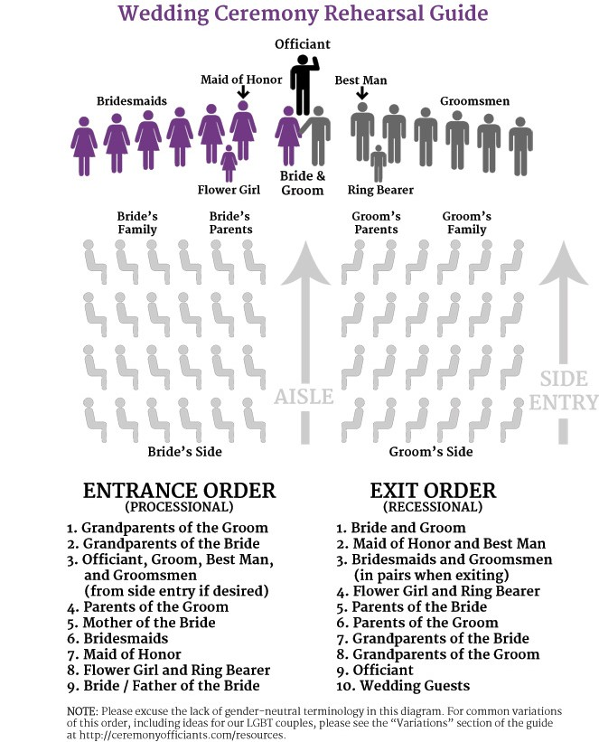

Grandparents of the Groom:
Grandparents of the Bride:
Officiant, Groom:
Parents of the Groom:
Mother of the Bride:
Bridesmaids/Groomsmen:
(in order, paired together or let us know if your bridesmaids will not be escorted by groomsmen, in that case they will walk out together with groom, please keep in mind that the best man and maid of honor will walk last)
Flower Girl/Ringbearer:
Bride / Father of the Bride:

Vendors
Please include a list of your vendors and contact phone number. Add any additional vendors you have hired if they are not listed below.

Wedding planner or day-of designated person:
Officiate (if ceremony is onsite):
Musicians or DJ for ceremony:
Photographer:
Videographer:
Florist:
Candles/Décor:
Bakery:
Band or DJ for reception:
Photobooth:
Transportation:
Rentals:

Floorplan Notes:
Our floorplans are located here on our website. They are designed based on the best flow of the space for an event of your size and type. These have been developed over many years of experience in hosting events. Please select a floorplan, if applicable. If you have any comments or requested changes, please include below so we can address these with you.
(Example- I would like to use the entry table for my guest book and picture frames of our engagement portraits. The florist will also place an arrangement here. OR I prefer the groom’s cake in the front parlor, do you recommend this?)
- Include any information regarding a rain plan.
- Let us know the configuration of the pavilion panels if different from our standard configuration which is the back L-shape solid panels are down and closed and the front L-shape windowed panels are up and open.
- Will you need any of the climate control amenities we include? If so, please list.
- Will you be renting any additional climate control items?
- Will you be renting any additional tables, chairs, linens, etc? If so, please include a detailed list below (all items must be removed from the venue the night of the event).

